**UNIIT-V: EMBRYONIC NUTRITION**

**Nutritional requirements of Embryo- modes of embryonic nutrition –Food reserve and embryonic nutrition- embryonic nutrition from mother –physiology of placenta**

**Definition of placenta:**

A placenta is an organ built up of maternal and foetal tissues jointly. It serves for the transport of nutrients from the mother tissues with those of the embryo as well as the exchange of gases between the tissues of the two. Thus a placenta may be defined as a temporary connection between the maternal and foetal tissues for the purpose of shelter, nutrition, respiration, excretion and defense.

**Development of placenta:**

When the mammalian embryo enters the uterus, it remains bathed in the uterine fluid containing organic substances produced by the tubular glands of the uterine wall. The early embryo may absorb some of these substances through the epithelial covering till the placenta formation. For its further development, the embryo completely depends on substances supplied to it from the maternal tissue.

A mammalian placenta is a composite structure based on double origin. It is produced by the development and apposition of extra-embryonic membranes (chorion, allantois or yolk sac) with the endometrium of the uterine wall (decidua basalis) which includes both the compact and spongy layers for the purpose of physiological exchange. In between these two parallel plates (the chorionic membrane and the endometrium) a huge blood sinus, the intervillous space, contains an enormous number of chorionic villi.

In mammalian placenta there are two possible sources of chorionic vascularization- the vitelline circulation provided by the allantois.

### Types:

On this basis, there exist two main types of mammalian placenta:

#### Chorio-vitelline placenta:

Some marsupials (Didelphis, Macropus), allantois remains relatively small and never makes contact with the chorion, where as the yolk-sac with its network of vitelline blood vessels becomes very large and fuses broadly with the chorion to complete a transitory yolk-sac placenta or chorio-vitelline placenta.

Further, the chorion never advances beyond a smooth membrane in close apposition with the vascular uterine endometrium. The uterine wall secretes a viscous fluid, the uterine milk. It is absorbed by the villi of yolk-sac placenta and through vitelline circulation is carried to the embryo.

#### Chorio-allantoic placenta:

In some other marsupials (Parameles, Dasyuris) and all the eutherian mammals, the yolk sac remains rudimentary but allantoic blood vessels are well developed. The allantois fuses with the chorion to form a composite membrane. This membrane serves as a component part of the so-called chorio-allantoic placenta.

The chorion grows out into root like vascular processes, the chorionic villi that engage the uterine mucosa in a more or less intimate functional relation persisting throughout pregnancy. Remnants of the chorio-vitelline placenta may be found either temporarily or even permanently in higher mammals playing a subsidiary role in their Placentation (Fig. 1). When the allantois is insignificant or lacking, the placenta is known as chorionic placenta.

**[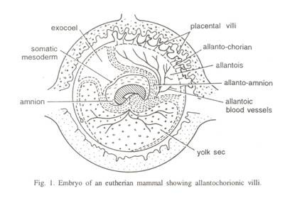](https://cdn.yourarticlelibrary.com/wp-content/uploads/2013/08/clip_image0027.jpg)**

#### Allanto-chorionie villi:

The chorionic villi are finger-like outgrowths that penetrate into depressions in the wall of the uterus through which all kinds of interchanges take place between the mother and the foetus. The early villi are compact, bush-like tufts with a few small branches. Their main stems arise from the chorionic membranes and almost all the eroded surfaces of compact endometrium (decidua basalis).

Side branches begin to develop in the early period of pregnancy and produce many villi as well. During the middle and late months of pregnancy, the villi become much more branched, tree like with permanent trunks and long and slender branches bearing innumerable small twigs.

Many terminal branches fuse with the decidua basalis of the endometrium at some distance from their ends, and then recurve into the inter-villous space in a shaped manner (Fig. 2). All parts of the villous tree have the same structural plan. At the center is a connective tissue core, in which are embedded the allantoic blood vessels (in case of chorioallantoic placenta) or the vitelline blood vessels (in case of chorio-vitelline placenta). 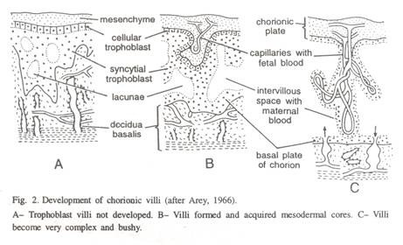

These appear as arterioles and venules but taper to prominent capillaries, which continue to the villous tips where they complete a continuous system of closed vessels. The connective tissue core is covered with a double layer of trophoblast.

Inside, next to the connective tissue, is a single layered cyto-trophoblast or cellular trophoblast with its separate cuboidal cells, it is also known as the layer of Langhans. The cellular layer gives rise to syncytium, the syntrophoblast, which covers the villi externally.

# PRE-IMPLANTATION EMBRYONIC DEVELOPMENT

Following fertilization, the zygote and its associated membranes, together referred to as the **conceptus**, continue to be projected toward the uterus by peristalsis and beating cilia. During its journey to the uterus, the zygote undergoes five or six rapid mitotic cell divisions. Although each **cleavage** results in more cells, it does not increase the total volume of the conceptus ([Figure 1](https://opentextbc.ca/anatomyandphysiology/chapter/28-2-embryonic-development/#fig-ch29_02_01)). Each daughter cell produced by cleavage is called a **blastomere** (blastos = “germ,” in the sense of a seed or sprout).

Approximately 3 days after fertilization, a 16-cell conceptus reaches the uterus. The cells that had been loosely grouped are now compacted and look more like a solid mass. The name given to this structure is the **morula** (morula = “little mulberry”). Once inside the uterus, the conceptus floats freely for several more days. It continues to divide, creating a ball of approximately 100 cells, and consuming nutritive endometrial secretions called uterine milk while the uterine lining thickens. The ball of now tightly bound cells starts to secrete fluid and organize themselves around a fluid-filled cavity, the **blastocoel**. At this developmental stage, the conceptus is referred to as a **blastocyst**. Within this structure, a group of cells forms into an **inner cell mass**, which is fated to become the embryo. The cells that form the outer shell are called **trophoblasts** (trophe = “to feed” or “to nourish”). These cells will develop into the chorionic sac and the fetal portion of the **placenta** (the organ of nutrient, waste, and gas exchange between mother and the developing offspring).

The inner mass of embryonic cells is totipotent during this stage, meaning that each cell has the potential to differentiate into any cell type in the human body. Totipotency lasts for only a few days before the cells’ fates are set as being the precursors to a specific lineage of cells.

During the late pregnancy the cyto-trophoblast of the villi becomes progressively more interrupted and hence scarcer. This is because of its complete use up and the syncytium forms the sole covering of the villi. Subsequently, it becomes permeated by a system of cavities-the trophoblastic lacunae.embryonic cleavages make use of the abundant cytoplasm of the conceptus as the cells rapidly divide without changing the total volume.

As the blastocyst forms, the trophoblast excretes enzymes that begin to degrade the zona pellucida. In a process called “hatching,” the conceptus breaks free of the zona pellucida in preparation for implantation

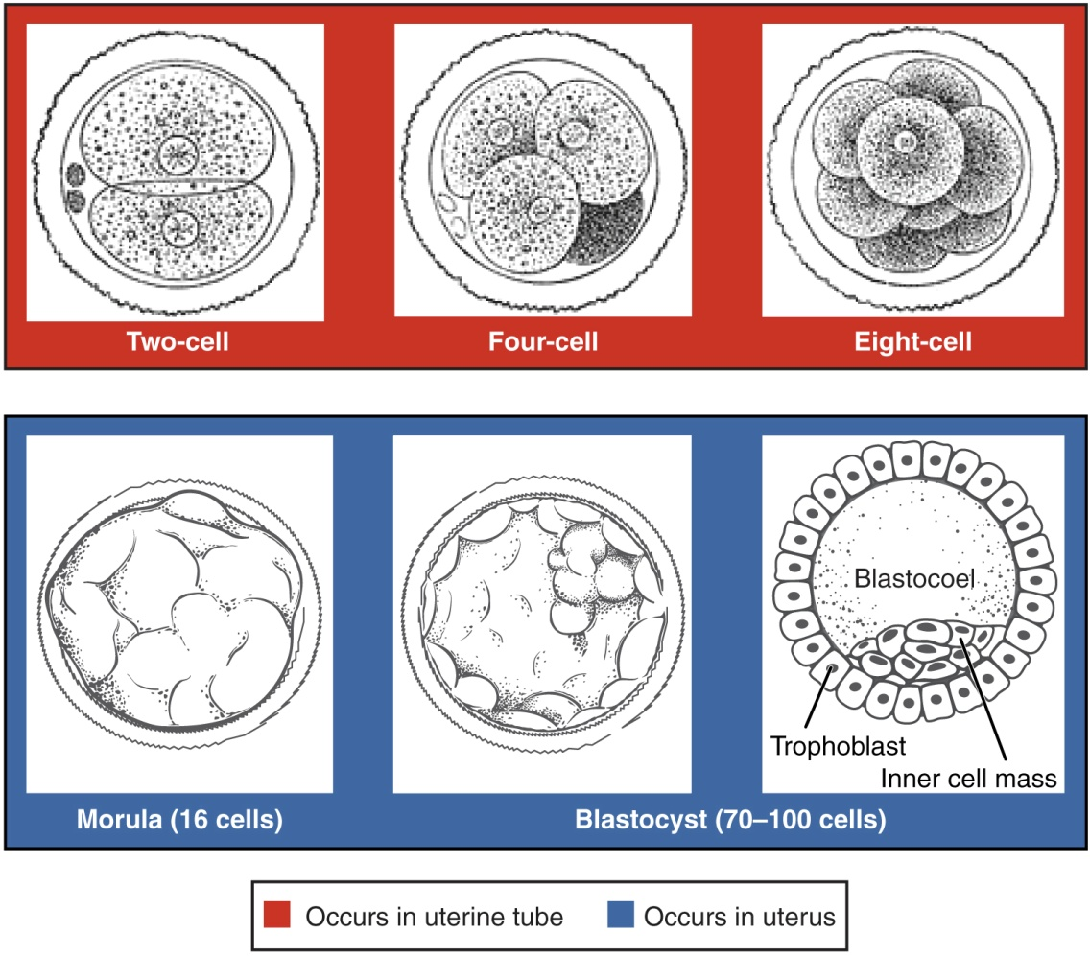

# IMPLANTATION

At the end of the first week, the blastocyst comes in contact with the uterine wall and adheres to it, embedding itself in the uterine lining via the trophoblast cells. Thus begins the process of **implantation**, which signals the end of the pre-embryonic stage of development ([Figure 2](https://opentextbc.ca/anatomyandphysiology/chapter/28-2-embryonic-development/#fig-ch29_02_02)). Implantation can be accompanied by minor bleeding. The blastocyst typically implants in the fundus of the uterus or on the posterior wall. However, if the endometrium is not fully developed and ready to receive the blastocyst, the blastocyst will detach and find a better spot. A significant percentage (50–75 percent) of blastocysts fail to implant; when this occurs, the blastocyst is shed with the endometrium during menses. The high rate of implantation failure is one reason why pregnancy typically requires several ovulation cycles to achieve.

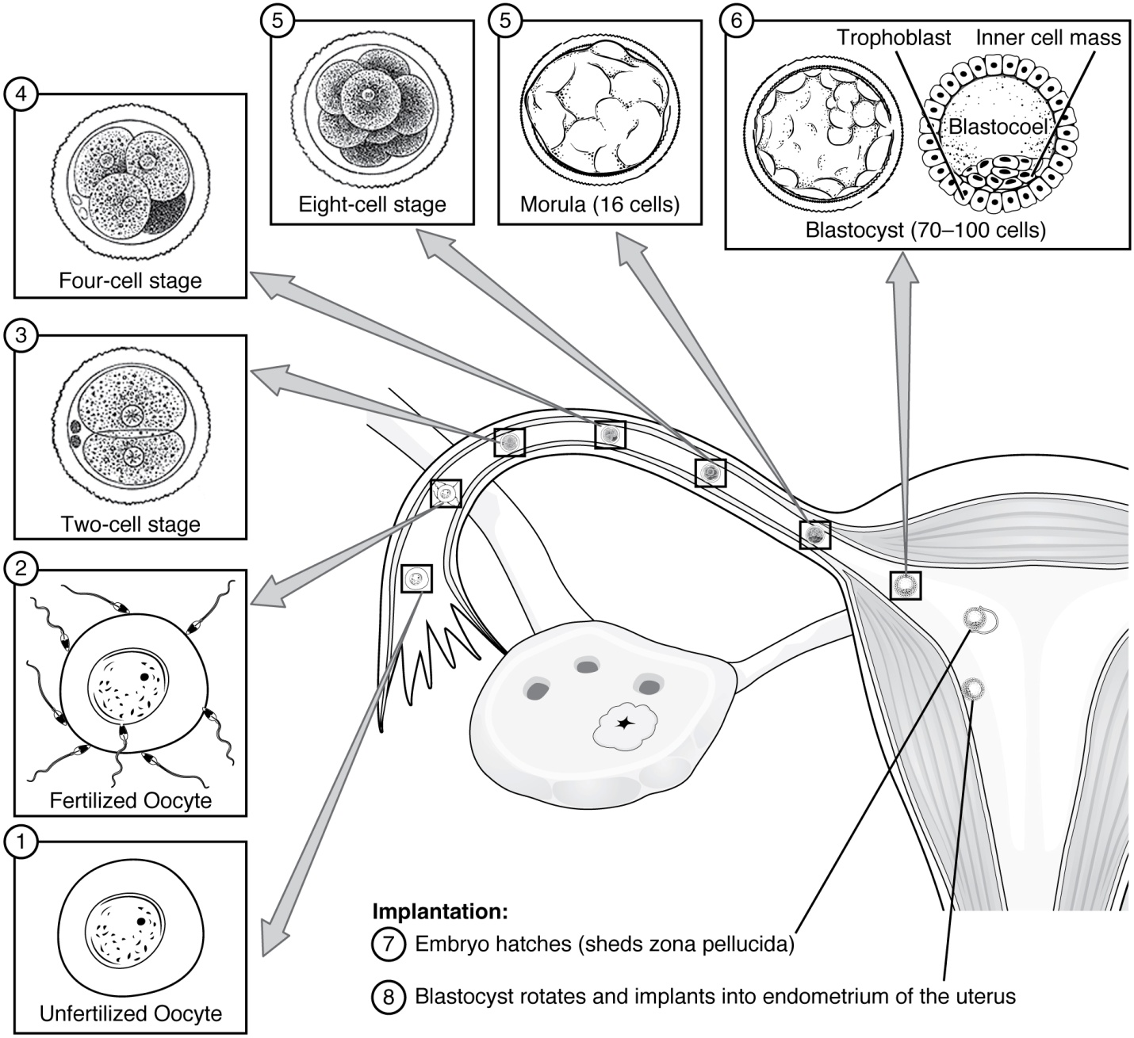

When implantation succeeds and the blastocyst adheres to the endometrium, the superficial cells of the trophoblast fuse with each other, forming the **syncytiotrophoblast**, a multinucleated body that digests endometrial cells to firmly secure the blastocyst to the uterine wall. In response, the uterine mucosa rebuilds itself and envelops the blastocyst ([Figure 3](https://opentextbc.ca/anatomyandphysiology/chapter/28-2-embryonic-development/#fig-ch29_02_03)). The trophoblast secretes **human chorionic gonadotropin (hCG)**, a hormone that directs the corpus luteum to survive, enlarge, and continue producing progesterone and estrogen to suppress menses. These functions of hCG are necessary for creating an environment suitable for the developing embryo. As a result of this increased production, hCG accumulates in the maternal bloodstream and is excreted in the urine. Implantation is complete by the middle of the second week. Just a few days after implantation, the trophoblast has secreted enough hCG for an at-home urine pregnancy test to give a positive result.

Most of the time an embryo implants within the body of the uterus in a location that can support growth and development. However, in one to two percent of cases, the embryo implants either outside the uterus (an **ectopic pregnancy**) or in a region of uterus that can create complications for the pregnancy. If the embryo implants in the inferior portion of the uterus, the placenta can potentially grow over the opening of the cervix, a condition call **placenta previa**.

Disorders of the…

**Development of the Embryo**  
In the vast majority of ectopic pregnancies, the embryo does not complete its journey to the uterus and implants in the uterine tube, referred to as a tubal pregnancy. However, there are also ovarian ectopic pregnancies (in which the egg never left the ovary) and abdominal ectopic pregnancies (in which an egg was “lost” to the abdominal cavity during the transfer from ovary to uterine tube, or in which an embryo from a tubal pregnancy re-implanted in the abdomen). Once in the abdominal cavity, an embryo can implant into any well-vascularized structure—the rectouterine cavity (Douglas’ pouch), the mesentery of the intestines, and the greater omentum are some common sites.Tubal pregnancies can be caused by scar tissue within the tube following a sexually transmitted bacterial infection. The scar tissue impedes the progress of the embryo into the uterus—in some cases “snagging” the embryo and, in other cases, blocking the tube completely. Approximately one half of tubal pregnancies resolve spontaneously. Implantation in a uterine tube causes bleeding, which appears to stimulate smooth muscle contractions and expulsion of the embryo. In the remaining cases, medical or surgical intervention is necessary. If an ectopic pregnancy is detected early, the embryo’s development can be arrested by the administration of the cytotoxic drug methotrexate, which inhibits the metabolism of folic acid. If diagnosis is late and the uterine tube is already ruptured, surgical repair is essential.Even if the embryo has successfully found its way to the uterus, it does not always implant in an optimal location (the fundus or the posterior wall of the uterus). Placenta previa can result if an embryo implants close to the internal os of the uterus (the internal opening of the cervix). As the fetus grows, the placenta can partially or completely cover the opening of the cervix ([Figure 4](https://opentextbc.ca/anatomyandphysiology/chapter/28-2-embryonic-development/#fig-ch29_02_04)). Although it occurs in only 0.5 percent of pregnancies, placenta previa is the leading cause of antepartum hemorrhage (profuse vaginal bleeding after week 24 of pregnancy but prior to childbirth).

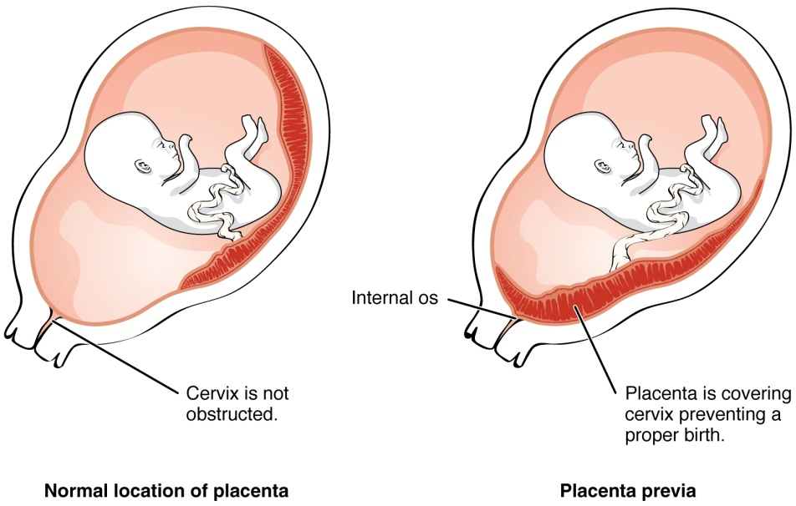

Figure 4. Placenta Previa. An embryo that implants too close to the opening of the cervix can lead to placenta previa, a condition in which the placenta partially or completely covers the cervix.

# EMBRYONIC MEMBRANES

During the second week of development, with the embryo implanted in the uterus, cells within the blastocyst start to organize into layers. Some grow to form the extra-embryonic membranes needed to support and protect the growing embryo: the amnion, the yolk sac, the allantois, and the chorion.

At the beginning of the second week, the cells of the inner cell mass form into a two-layered disc of embryonic cells, and a space—the **amniotic cavity**—opens up between it and the trophoblast ([Figure 5](https://opentextbc.ca/anatomyandphysiology/chapter/28-2-embryonic-development/#fig-ch29_02_05)). Cells from the upper layer of the disc (the **epiblast**) extend around the amniotic cavity, creating a membranous sac that forms into the **amnion** by the end of the second week. The amnion fills with amniotic fluid and eventually grows to surround the embryo. Early in development, amniotic fluid consists almost entirely of a filtrate of maternal plasma, but as the kidneys of the fetus begin to function at approximately the eighth week, they add urine to the volume of amniotic fluid. Floating within the amniotic fluid, the embryo—and later, the fetus—is protected from trauma and rapid temperature changes. It can move freely within the fluid and can prepare for swallowing and breathing out of the uterus.

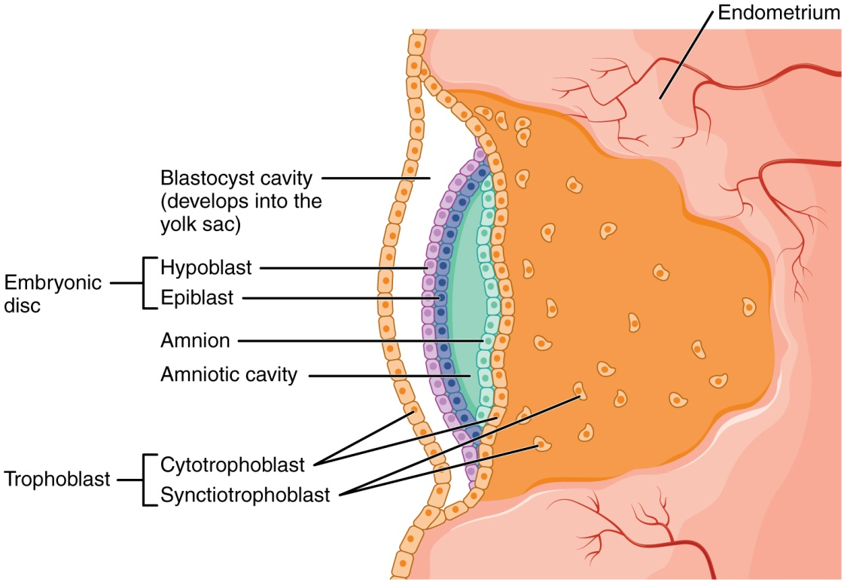

On the ventral side of the embryonic disc, opposite the amnion, cells in the lower layer of the embryonic disk (the **hypoblast**) extend into the blastocyst cavity and form a **yolk sac**. The yolk sac supplies some nutrients absorbed from the trophoblast and also provides primitive blood circulation to the developing embryo for the second and third week of development. When the placenta takes over nourishing the embryo at approximately week 4, the yolk sac has been greatly reduced in size and its main function is to serve as the source of blood cells and germ cells (cells that will give rise to gametes). During week 3, a finger-like outpocketing of the yolk sac develops into the **allantois**, a primitive excretory duct of the embryo that will become part of the urinary bladder. Together, the stalks of the yolk sac and allantois establish the outer structure of the umbilical cord.The last of the extra-embryonic membranes is the **chorion**, which is the one membrane that surrounds all others. The development of the chorion will be discussed in more detail shortly, as it relates to the growth and development of the placenta.

**EMBRYOGENESIS**

As the third week of development begins, the two-layered disc of cells becomes a three-layered disc through the process of **gastrulation**, during which the cells transition from totipotency to multipotency. The embryo, which takes the shape of an oval-shaped disc, forms an indentation called the **primitive streak** along the dorsal surface of the epiblast. A node at the caudal or “tail” end of the primitive streak emits growth factors that direct cells to multiply and migrate. Cells migrate toward and through the primitive streak and then move laterally to create two new layers of cells. The first layer is the **endoderm**, a sheet of cells that displaces the hypoblast and lies adjacent to the yolk sac. The second layer of cells fills in as the middle layer, or **mesoderm**. The cells of the epiblast that remain (not having migrated through the primitive streak) become 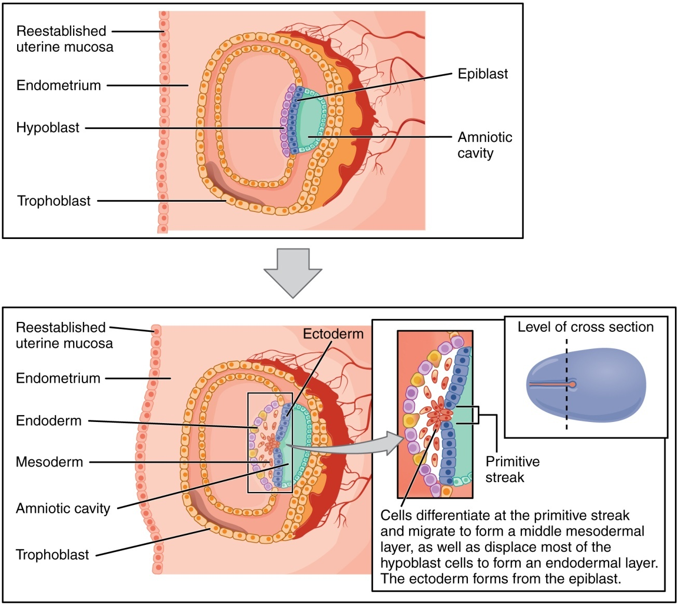

Each of these germ layers will develop into specific structures in the embryo. Whereas the ectoderm and endoderm form tightly connected epithelial sheets, the mesodermal cells are less organized and exist as a loosely connected cell community. The ectoderm gives rise to cell lineages that differentiate to become the central and peripheral nervous systems, sensory organs, epidermis, hair, and nails. Mesodermal cells ultimately become the skeleton, muscles, connective tissue, heart, blood vessels, and kidneys. The endoderm goes on to form the epithelial lining of the gastrointestinal tract, liver, and pancreas, as well as the lungs

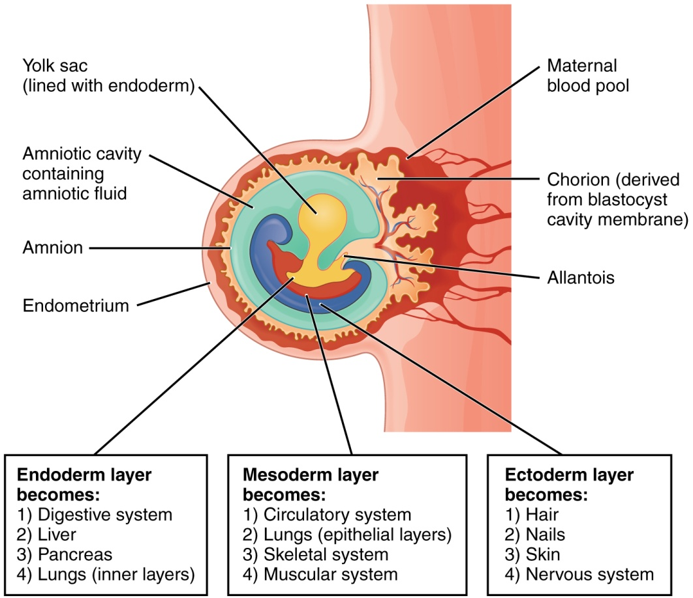

# DEVELOPMENT OF THE PLACENTA

During the first several weeks of development, the cells of the endometrium—referred to as decidual cells—nourish the nascent embryo. During prenatal weeks 4–12, the developing placenta gradually takes over the role of feeding the embryo, and the decidual cells are no longer needed. The mature placenta is composed of tissues derived from the embryo, as well as maternal tissues of the endometrium. The placenta connects to the conceptus via the **umbilical cord**, which carries deoxygenated blood and wastes from the fetus through two umbilical arteries; nutrients and oxygen are carried from the mother to the fetus through the single umbilical vein. The umbilical cord is surrounded by the amnion, and the spaces within the cord around the blood vessels are filled with Wharton’s jelly, a mucous connective tissue.

The maternal portion of the placenta develops from the deepest layer of the endometrium, the decidua basalis. To form the embryonic portion of the placenta, the syncytiotrophoblast and the underlying cells of the trophoblast (cytotrophoblast cells) begin to proliferate along with a layer of extraembryonic mesoderm cells. These form the **chorionic membrane**, which envelops the entire conceptus as the chorion. The chorionic membrane forms finger-like structures called **chorionic villi** that burrow into the endometrium like tree roots, making up the fetal portion of the placenta. The cytotrophoblast cells perforate the chorionic villi, burrow farther into the endometrium, and remodel maternal blood vessels to augment maternal blood flow surrounding the villi. Meanwhile, fetal mesenchymal cells derived from the mesoderm fill the villi and differentiate into blood vessels, including the three umbilical blood vessels that connect the embryo to the developing placenta ([Figure 8](https://opentextbc.ca/anatomyandphysiology/chapter/28-2-embryonic-development/#fig-ch29_02_08)).

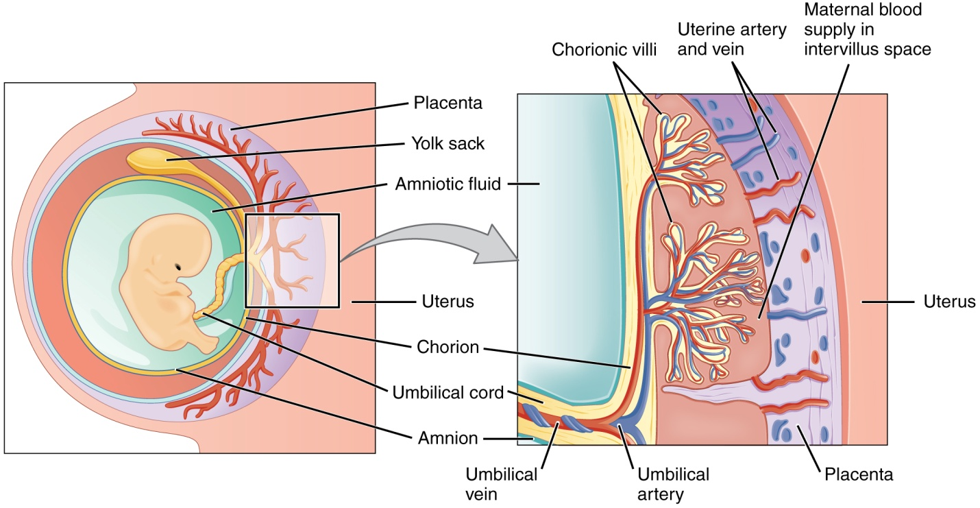Figure 8. Cross-Section of the Placenta. In the placenta, maternal and fetal blood components are conducted through the surface of the chorionic villi, but maternal and fetal bloodstreams never mix directly.

The placenta develops throughout the embryonic period and during the first several weeks of the fetal period; **placentation** is complete by weeks 14–16. As a fully developed organ, the placenta provides nutrition and excretion, respiration, and endocrine function ([Table 1](https://opentextbc.ca/anatomyandphysiology/chapter/28-2-embryonic-development/#tbl-ch29_01) and [Figure 9](https://opentextbc.ca/anatomyandphysiology/chapter/28-2-embryonic-development/#fig-ch29_02_09)). It receives blood from the fetus through the umbilical arteries. Capillaries in the chorionic villi filter fetal wastes out of the blood and return clean, oxygenated blood to the fetus through the umbilical vein. Nutrients and oxygen are transferred from maternal blood surrounding the villi through the capillaries and into the fetal bloodstream. Some substances move across the placenta by simple diffusion. Oxygen, carbon dioxide, and any other lipid-soluble substances take this route. Other substances move across by facilitated diffusion. This includes water-soluble glucose. The fetus has a high demand for amino acids and iron, and those substances are moved across the placenta by active transport.

Maternal and fetal blood does not commingle because blood cells cannot move across the placenta. This separation prevents the mother’s cytotoxic T cells from reaching and subsequently destroying the fetus, which bears “non-self” antigens. Further, it ensures the fetal red blood cells do not enter the mother’s circulation and trigger antibody development (if they carry “non-self” antigens)—at least until the final stages of pregnancy or birth. This is the reason that, even in the absence of preventive treatment, an Rh− mother doesn’t develop antibodies that could cause hemolytic disease in her first Rh+ fetus.

Although blood cells are not exchanged, the chorionic villi provide ample surface area for the two-way exchange of substances between maternal and fetal blood. The rate of exchange increases throughout gestation as the villi become thinner and increasingly branched. The placenta is permeable to lipid-soluble fetotoxic substances: alcohol, nicotine, barbiturates, antibiotics, certain pathogens, and many other substances that can be dangerous or fatal to the developing embryo or fetus. For these reasons, pregnant women should avoid fetotoxic substances. Alcohol consumption by pregnant women, for example, can result in a range of abnormalities referred to as fetal alcohol spectrum disorders (FASD). These include organ and facial malformations, as well as cognitive and behavioral disorders.

| **Functions of the Placenta (Table 1)** | | |
| --- | --- | --- |
| **Nutrition and digestion** | **Respiration** | **Endocrine function** |
| * Mediates diffusion of maternal glucose, amino acids, fatty acids, vitamins, and minerals * Stores nutrients during early pregnancy to accommodate increased fetal demand later in pregnancy * Excretes and filters fetal nitrogenous wastes into maternal blood | * Mediates maternal-to-fetal oxygen transport and fetal-to-maternal carbon dioxide transport | * Secretes several hormones, including hCG, estrogens, and progesterone, to maintain the pregnancy and stimulate maternal and fetal development * Mediates the transmission of maternal hormones into fetal blood and vice versa |